Creating the First Jenkins Job(CI)

* Before working with CI in Jenkins make sure JDK, Git and Maven was installed in your system and path was set in the environment variables.
* If not please install the JDK7 or higher version and Maven latest version. Then only you are able to work with CI’s in Jenkins.
* To start with CI in Jenkins we need a project. Here I’m taking a sample project from GitHub.
* <https://github.com/wakaleo/game-of-life.git>

Let’s Begin

* Go to the Jenkins Dash Board
* Click on the New-Item.
* Enter the Name of the project and select the project as FreeStyle project.

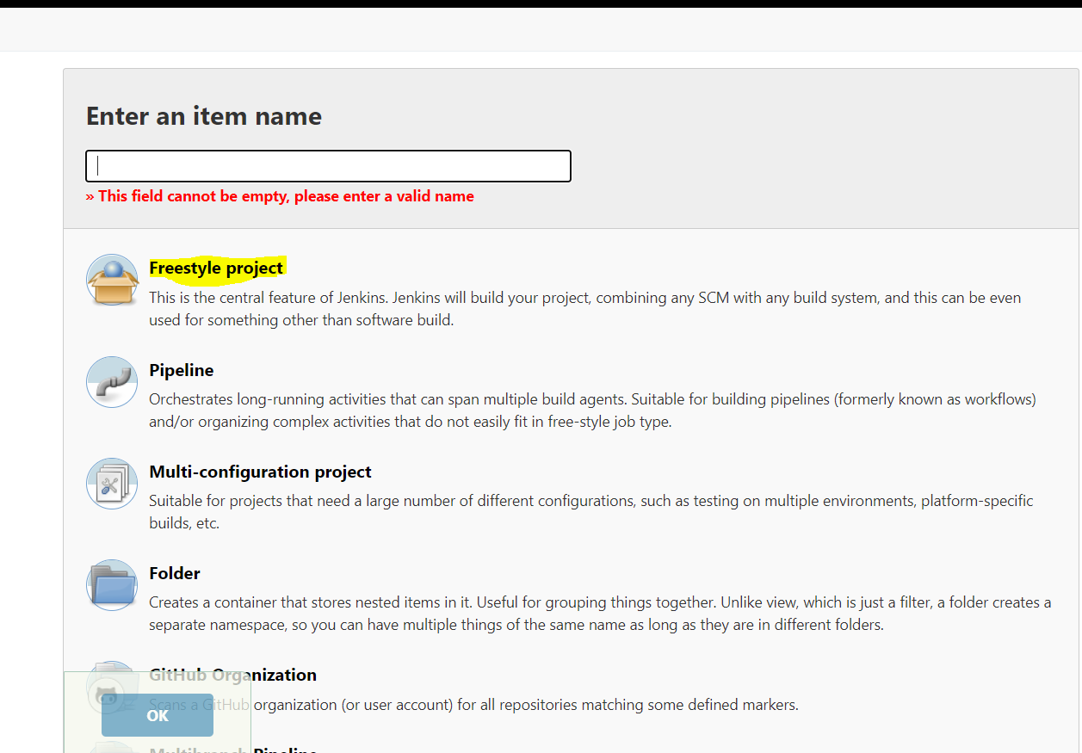

* And Click on the OK button.

Step 1 :-

General:

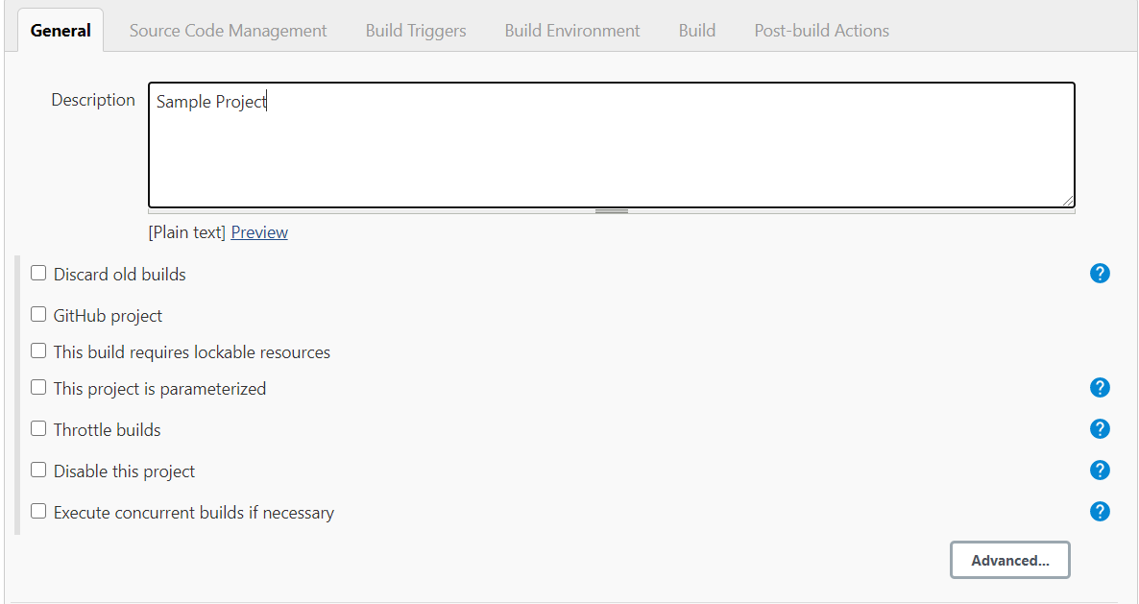

Description: Sample Project

Check on the Discard old builds.

Days to keep the builds: 5

Max of builds to keep: 5 Days

Step 2:-

Source Management:

* + - Git
    - Repository Url: <https://github.com/wakaleo/game-of-life.git>
    - Credentials: None
    - Branch to build: Select your Branch
    - In this case Master branch
    - Repository browser: Auto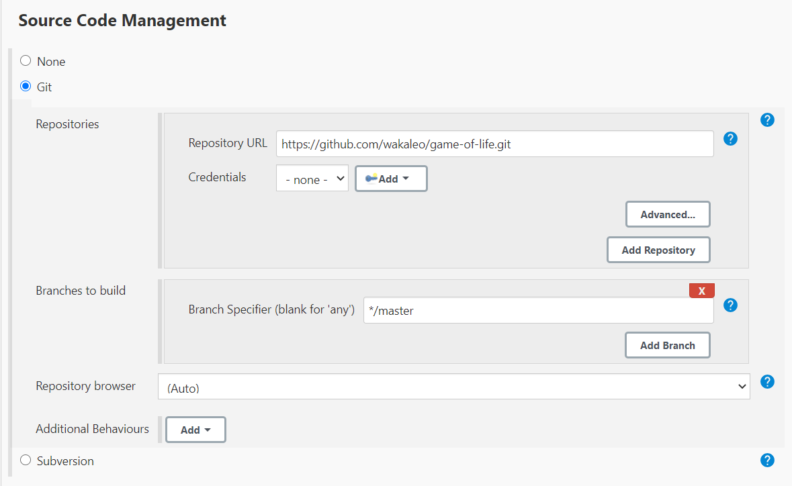

Step 3:

Build Triggers

Check Poll SCM

Schedule - * * * * *(Five stars, space between each star it means build will trigger every 1 min.

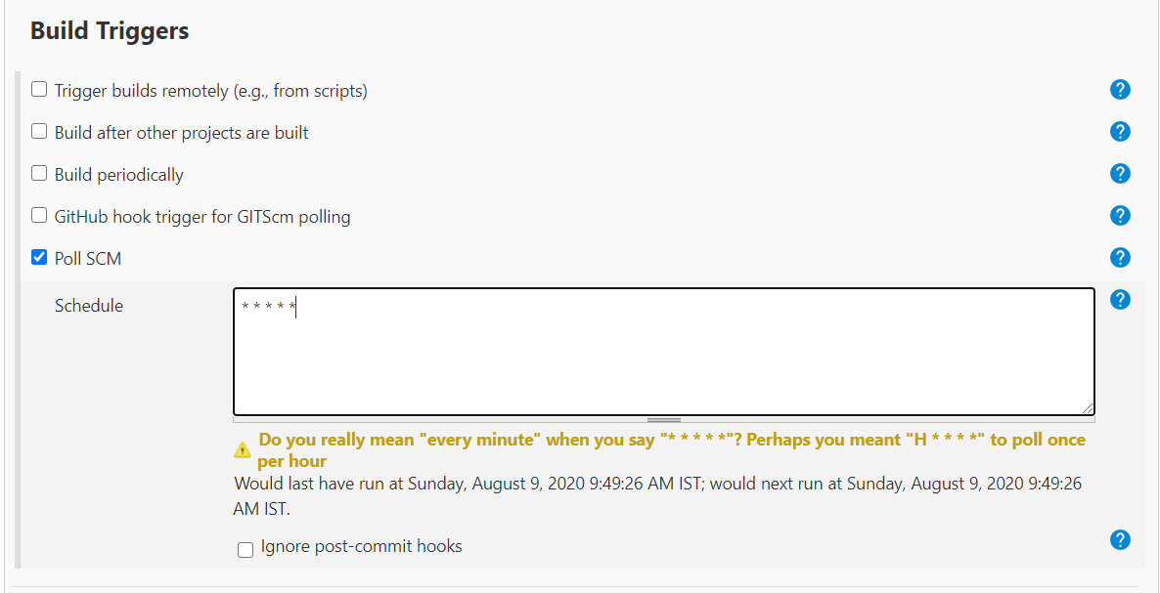

Step 4:

Build Environment-

Check Add timestamps to the console output

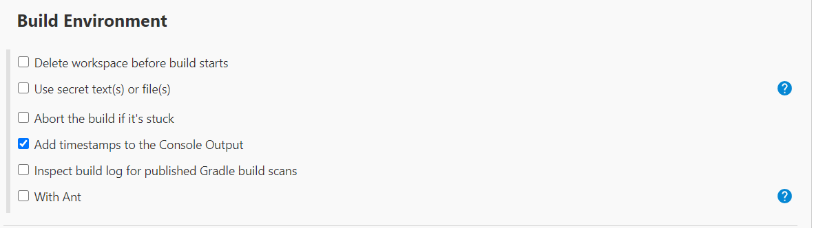

Step 5:

Build-

* Click on the Add build step and select **Invoke top level Maven targets**.
* Select Maven Version as **Default** one and Goals as **clean.**

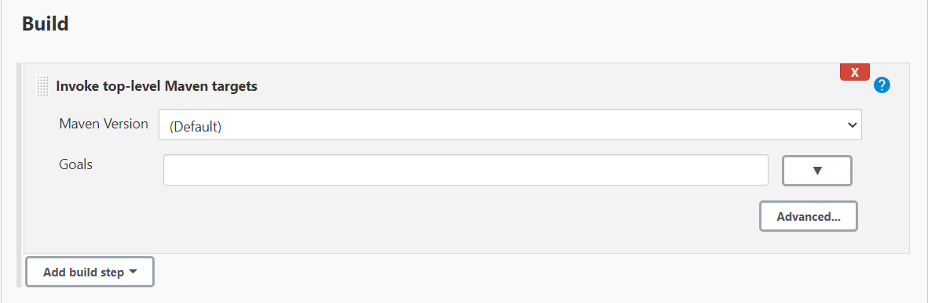

Step 6:

Post Build-Actions

Leave as it is as of now.

For more info <https://plugins.jenkins.io/postbuild-task/>

* Finally click on the Apply and Save button.
* Now your build triggered automatically.

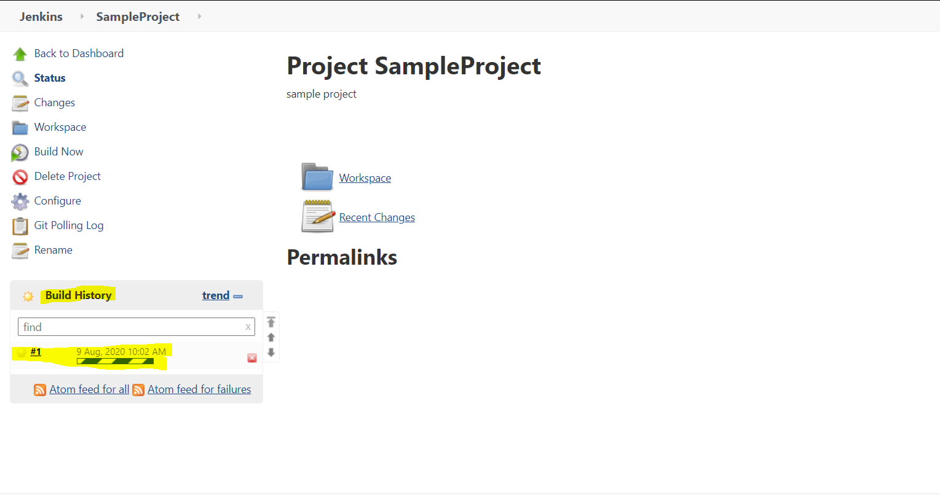

To check the build log click on #1. And then click on the console output.

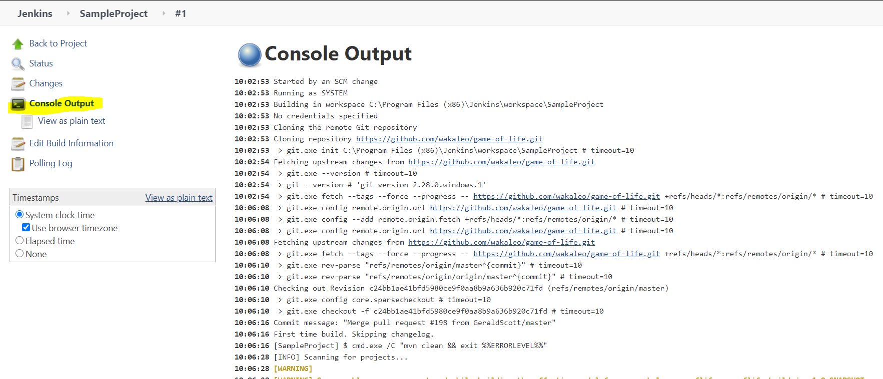

You can find the status of your build on the below of the Console Output.

Note: If you want do any changes to your build click on the Configure link in Project Dash Board.

